**LABORATORY 10**

**-NAND TTL-**

**1)TR analysis**

**->code**

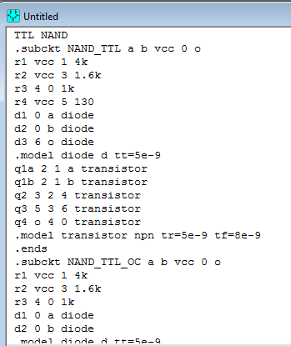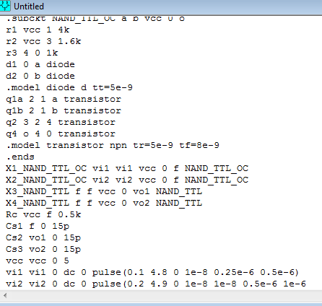

**->graph**

**2)DC analysis**

**->code**

**->graph:**

**2)**

**->code**

**->graphs:**

